**CONNECTING POWER BI AND MYSQL DATABASE**

We will have to install the MySQL Connector using this link:

<https://dev.mysql.com/downloads/connector/net/>

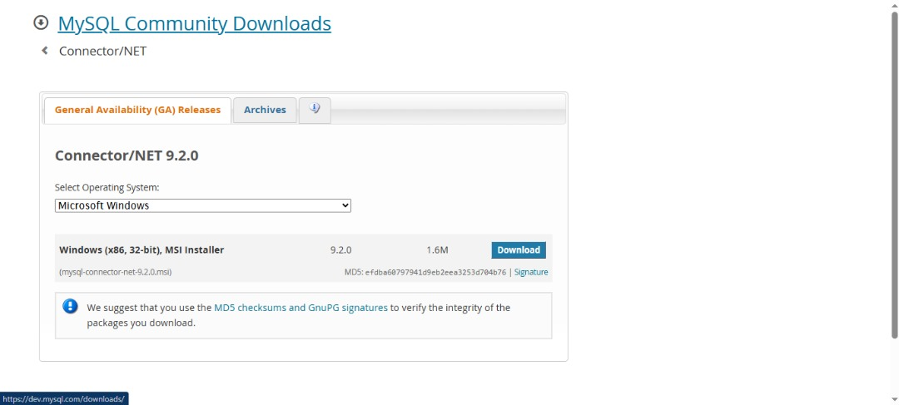

Then we click on start download after choosing for your particular OS

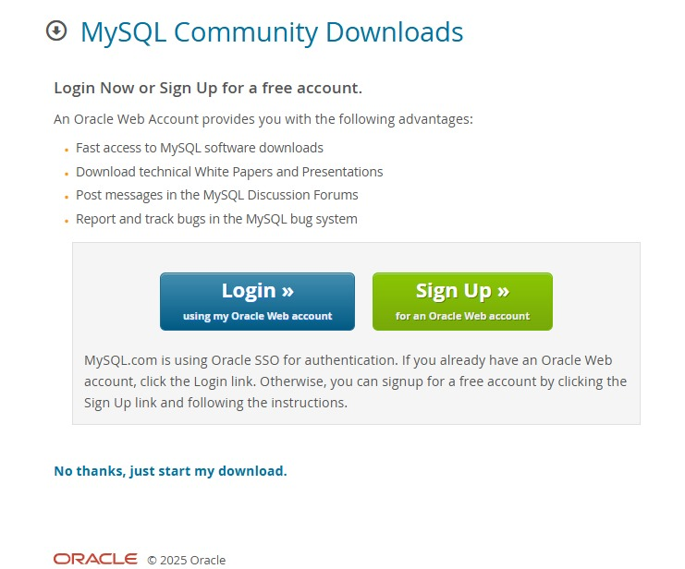

Then you click on the downloaded connector and installation starts immediately.

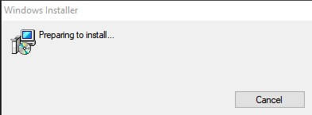

Follow thru with the installation to the end.

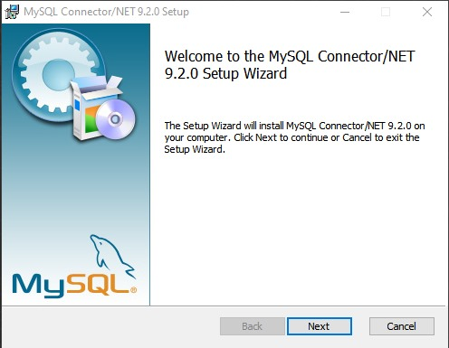

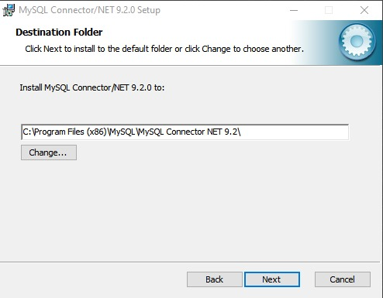

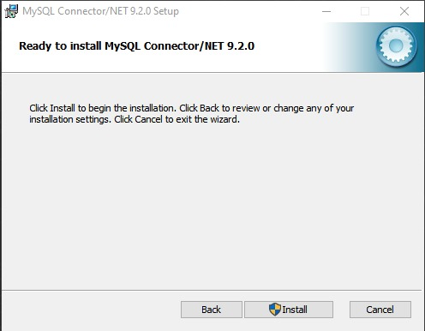

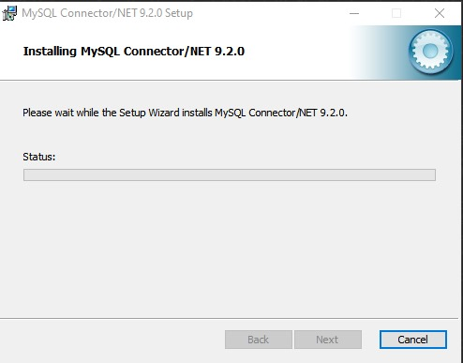

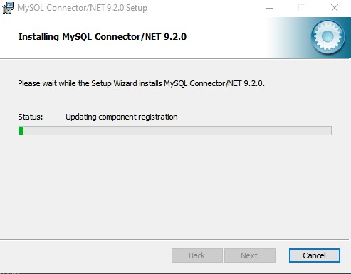

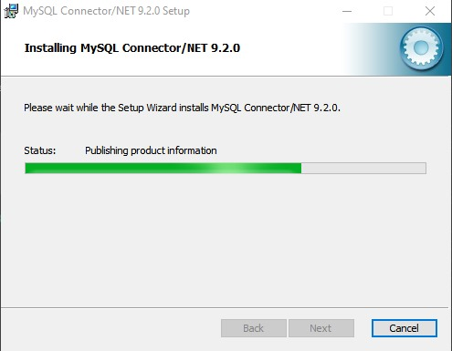

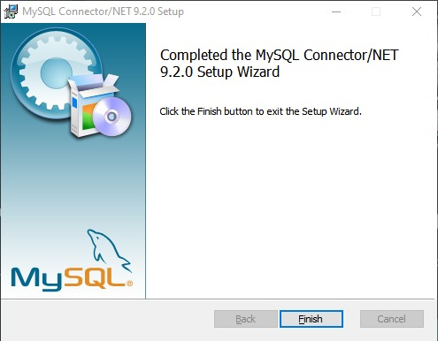

After successfully installing the Connector, then we can connect our Power BI with our MySQL Database to import data from there directly.

Which is shown in the below snippets, but we will show this practically.

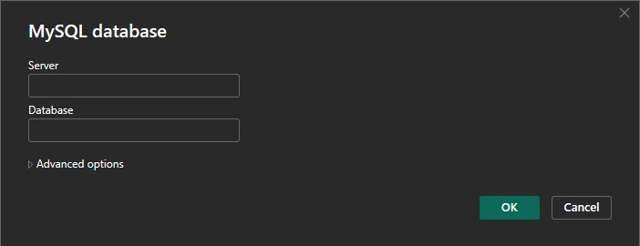

We put our credentials here which is shown below:

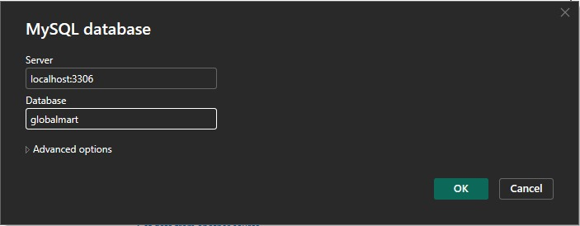

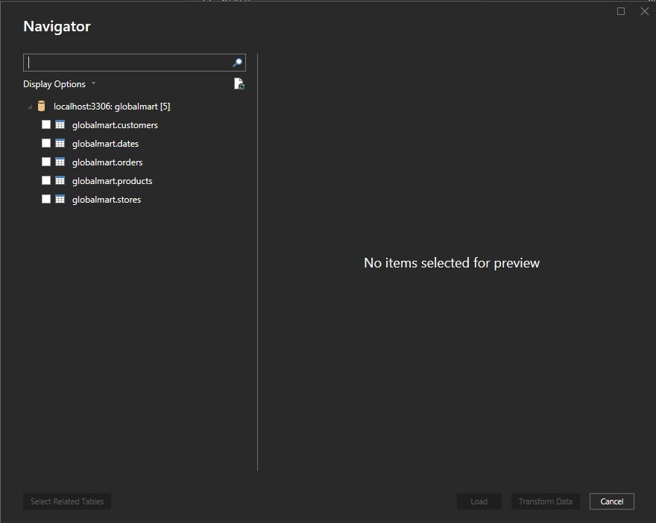

Then we tick the boxes to choose our tables in the MySQL DataBase

